Introduction
There was a time when a standard installation of the Microsoft Windows operating system would carry with it a bundle of relatively simple yet incredibly enjoyable games. Many of these games were adapted to work with a mouse and keyboard – card games such as Hearts and Solitaire, the board game Chess, and even a version of pinball – but some of them were developed directly for computers, such as Minesweeper.
Minesweeper is an inherently simple game. The player is presented with a grid of squares, a number of which are covering mines. The size of the grid and the number of mines are increased or decreased depending on the difficulty selected. For Easy difficulty, there are 10 mines contained in a 9x9 grid; for Medium difficulty, there are 40 mines contained in a 16x16 grid; and for Hard difficulty, there are 99 mines contained in a 30x16 grid. The objective is to clear all squares that do not have a mine underneath them. Upon clearing a square, whatever is underneath the square is exposed, either a number, a blank square, or a mine. If a mine is uncovered, the player loses.
If a square is cleared and a mine is not uncovered, the square underneath will either reveal a number or a blank square. These types of squares indicate how many mines are adjacent to the square that was cleared. For example, if upon clearing a square the number “3” is revealed, that means that the cleared square is touching 3 squares with mines underneath (because a single square can be in contact with at most eight squares, the highest number that can be displayed upon clearing a square is “8”). Making deductions based off of this information, the player has to work their way across the grid, clearing squares that are not covering mines. When a player believes that they have discovered a square with a mine underneath it, they can place a flag on that square to avoid clearing it by mistake.
The next game to be adapted into a module is one that is synonymous with a lack of productivity: Solitaire. Solitaire is a single-player card game in which the player must organize all 52 cards in a standard deck into increasing order by their suit. In Solitaire, the lowest card in the suit is considered the Ace, with the highest card being the King.
The basic structures of a game of Solitaire are the deck, the piles, and the foundations. A foundation is the place where the cards are stacked in increasing order, and is the final location for the cards. These each correspond to a single suit, which is decided when the Ace is placed. All of the cards initially make up the deck, which is shuffled and then dealt in a specific fashion to make up the piles. There are seven piles in total, and each pile begins with a different number of cards in them, which increases by one from left to right as the piles are dealt: the leftmost pile has one card and the rightmost pile has seven. After the piles are dealt, the last card to be dealt in each pile is flipped over such that its face is showing. From here, the game can begin.
Any card that is in the face-up position can be moved to either a pile or a foundation. To move a card to a pile, the card must be:
    - of a different color suit than the card onto which it is being placed (for example, a red Hearts card can be placed on a black Spades card, but a Hearts card cannot be placed on a red Diamonds card)
    - must be exactly one unit lower in value than the card onto which it is being placed (for example, a card of value Eight can only be placed on a card with a value of Nine)
To move a card to a foundation, the card must be:
    - of the exact same suit as the foundation, unless it is an Ace which designates the formation of the foundation and sets the suit of the foundation
    - must be exactly one unit higher in value than the card onto which it is being placed (for example, a card of value Eight can only be placed on a card with a value of Seven)
A card can be moved from a foundation, from a pile, or when it is turned over from the deck. In the version of Solitaire implemented in this project, one card is turned over from the deck at a time (other versions include flipping three cards at a time, which is considered more difficult). When this card is turned over, it can be played. Multiple cards can be moved between piles at the same time, as long as the first card being moved follows the rules laid out for pile movement. Cards must be placed onto foundations individually.
In addition to turning over cards from the deck, the player can turn over cards from a pile when there are no longer any face-up cards in that pile (only piles two to seven have face-down cards in them). Also, when a pile no longer has any cards in it – either face-up or faced-down – the player can place a King of any suit onto the empty pile. The player must remember that only seven piles can exist at any one time.
Hearts is a more complicated game than Solitaire, though it is still played with the same standard deck of 52. Unlike Solitaire, it is a game meant for four players, and unlike most other games, the objective of Hearts is to score as few points as possible. Hearts is considered a “trick-taking” game, in that rounds of Hearts are divided into playing “tricks,” during which each player plays a single card.
To set up a game of Hearts, a deck of 52 cards are shuffled and dealt out completely to each of the four players (a deck of 52 cards divided into four players means that each player gets 13 cards). Before the round begins, each player chooses three cards to pass in a certain direction. This direction changes every time the round ends, and alternates between passing to the left, across, and to the right. A round begins by the player who has the Two of Clubs, and this card must be played first. Play continues in a clockwise order until all four players have placed a card. These four cards are make up a single trick.
When a player places the first card of the trick, the trick takes the suit of that card. From then on, the remaining players can only place a card of the trick suit, unless they no longer have any cards of that suit. Then the player can place any card they wish. The player wins the trick if they placed the highest card of the trick suit, and the round ends when each player has placed all of the cards in their hand – because every player must play a card for each trick, each round lasts 13 tricks.
A player cannot play a Hearts card as the first card on any trick until someone plays a Hearts card during turns two to four of a trick. In order for this to happen, the player who plays the first Hearts card must first run out of cards of the suit of one of the tricks. Neither a Hearts card or the Queen of Spades can be played in the first trick.
When the round has ended, each player receives a score for that round based on the cards in the tricks they won throughout the round. Every Hearts card the player won is worth one point, while the Queen of Spades is worth 13 points. After each round, the score for that round is added to a single total score for each player. The rounds continue until at least one player has totaled 100 points, at which point the player with the least amount of total points across all of the rounds wins.
User Manual
Installation and Launching
The project comes as the runnable Games.jar file packaged in a main folder alongside a folder called /res. This folder is important and necessary, as it contains the image assets used in the game. The games cannot be played without this folder.
Playing the Games
When the Games.jar file is run, the main menu is opened. From here, any of the three game modules can be launched:
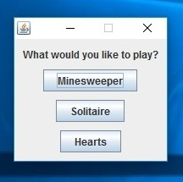
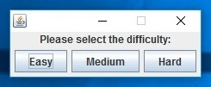
If minesweeper is selected, the user must first select the difficulty at which they would like to play:

Minesweeper is played by left-clicking on the squares to clear them while trying to avoid clearing the squares with mines underneath. When a square is cleared to reveal a number, that number indicates the amount of adjacent squares to the cleared square that have mines underneath them. The player can right-click to place a flag on a square, which then marks the square has having a mine underneath it, and also disables the clicking of the square. Also, the player can middle-click to clear multiple squares at once.
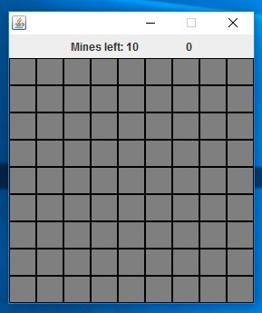
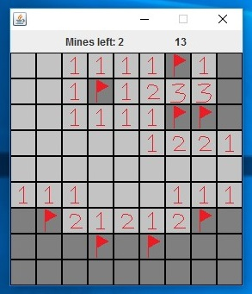
The beginning of a game of Minesweeper
The middle of a game of Minesweeper
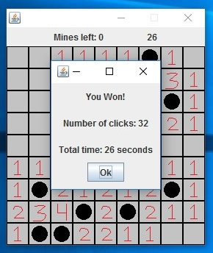
The end of a game of Minesweeper
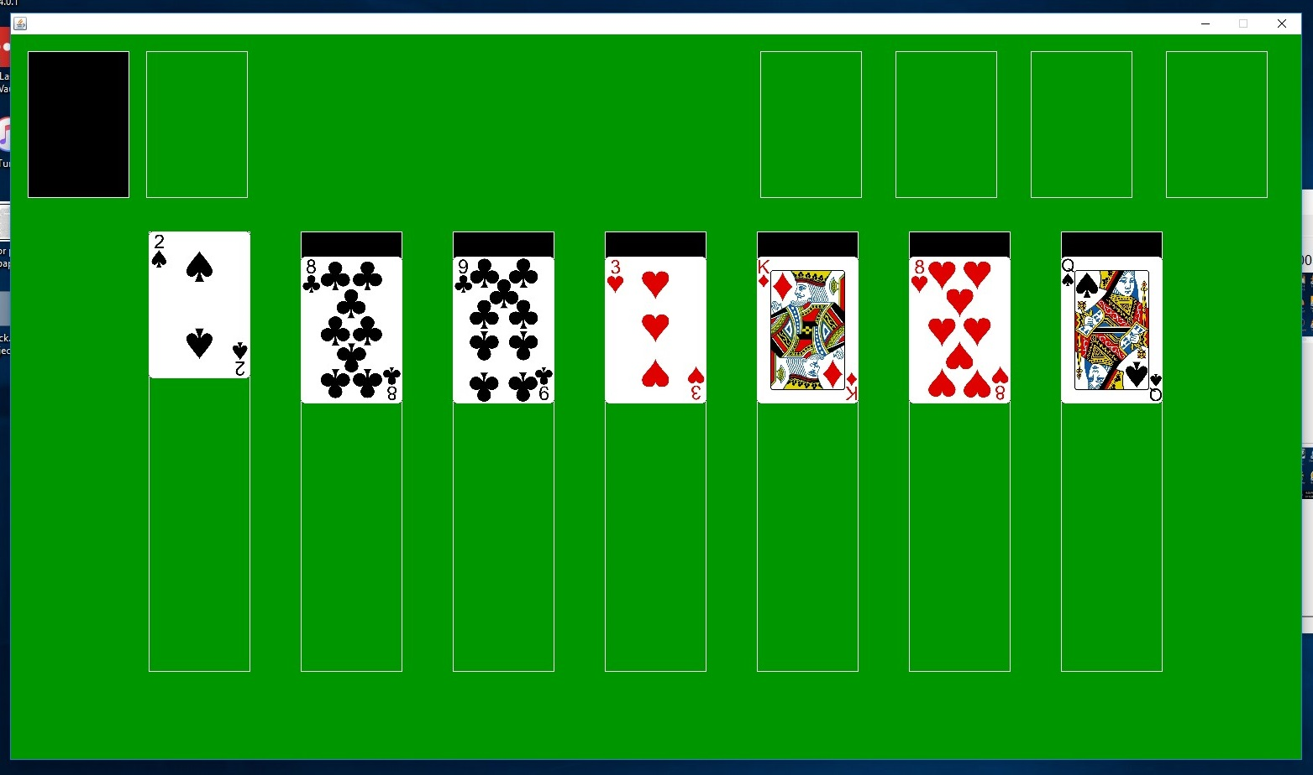
When Solitaire is loaded, the standard deck of cards is dealt into piles and the rest make up the deck.
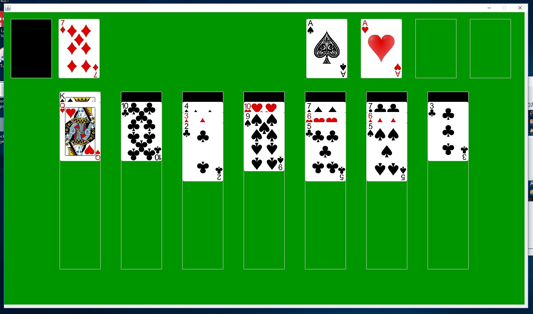
Cards can be dragged to and from the stack of cards drawn from the deck as well as between piles. Ultimately, the goal is to arrange all cards in the foundations as a stack of cards, increasing from Ace to King. A card is drawn from a deck or a pile by left-clicking on the appropriate spot.
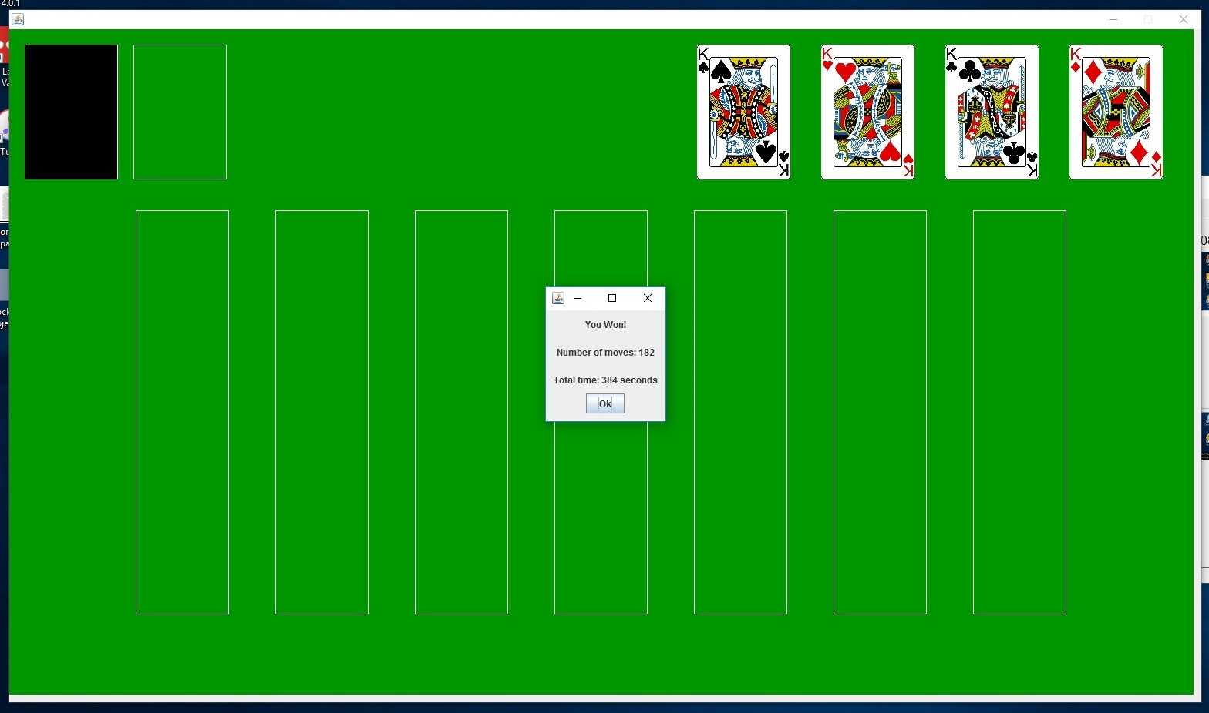
Like Solitaire, when a game of Hearts is loaded, all of the cards are dealt.
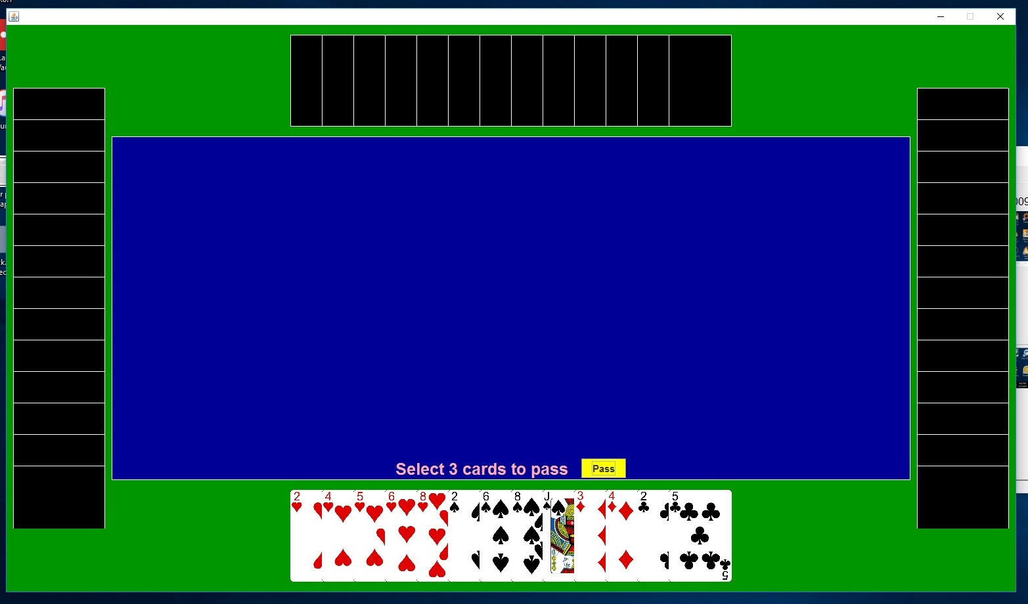
The beginning of a game of Hearts
At the beginning of each round, the user must select exactly three cards to pass. This is done by clicking on three cards to pass and then clicking the “Pass” button. Cards can be deselected by clicking on them again.

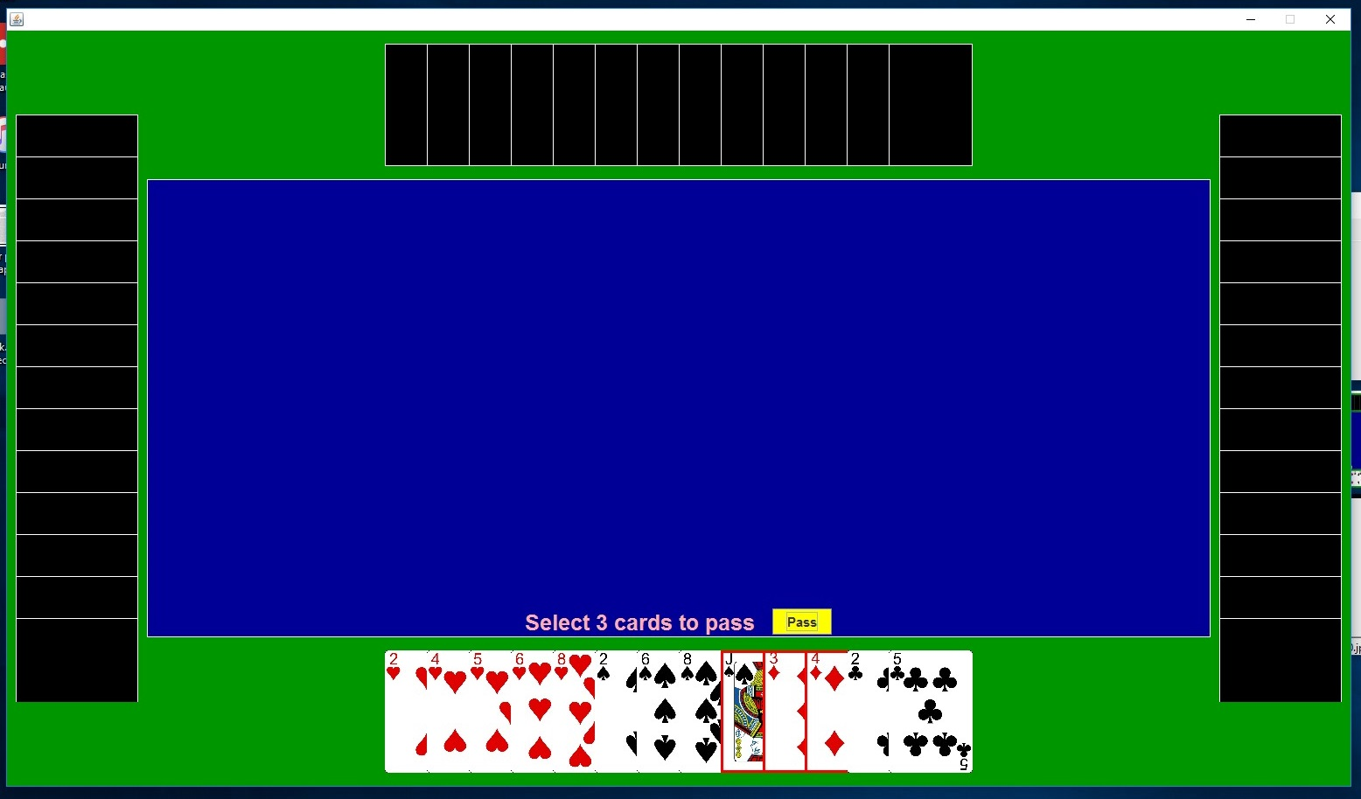
Selecting cards to pass

When it is the player's turn, they can select a card to play by left-clicking on it. The card must be of the same suit as the trick card (the first card placed in the trick), and can only be different if the player has no cards remaining of that suit. A card in the suit of Hearts cannot be played as t he trick card until a player plays a Hearts card in the middle of a trick.
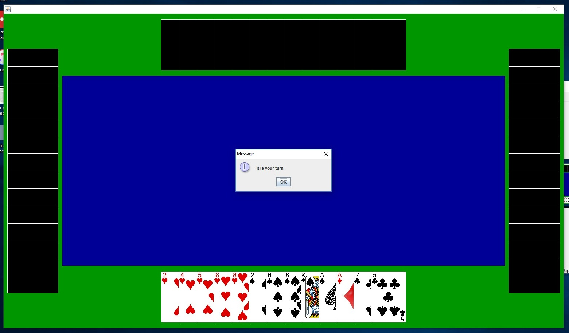
The player's turn being announced
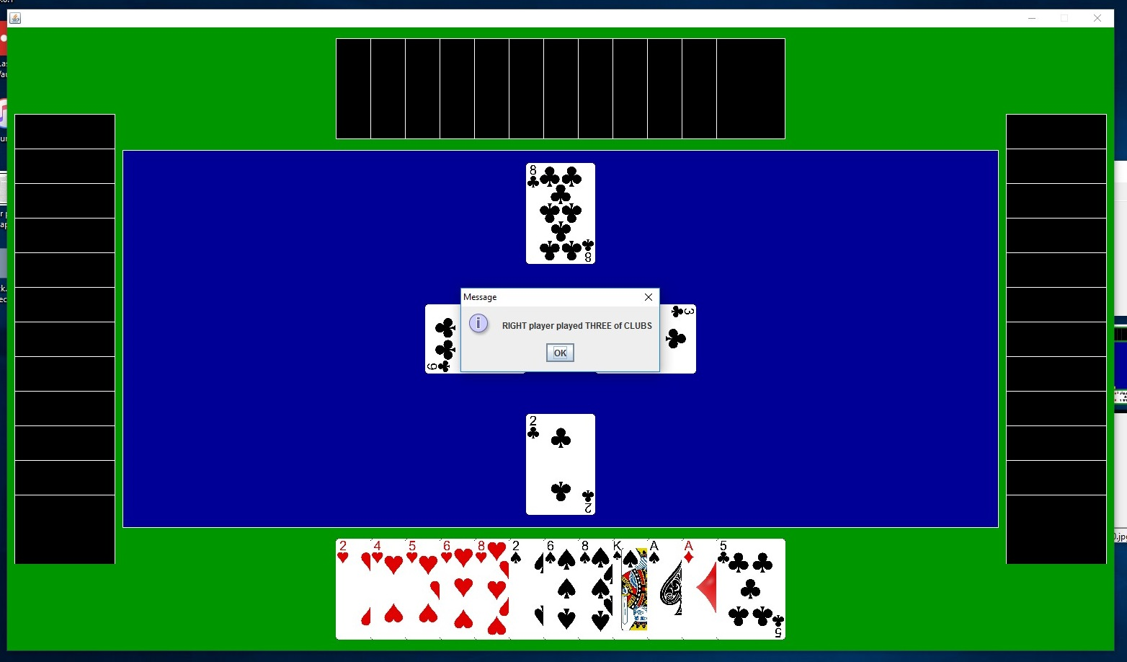
A computer's turn being announced
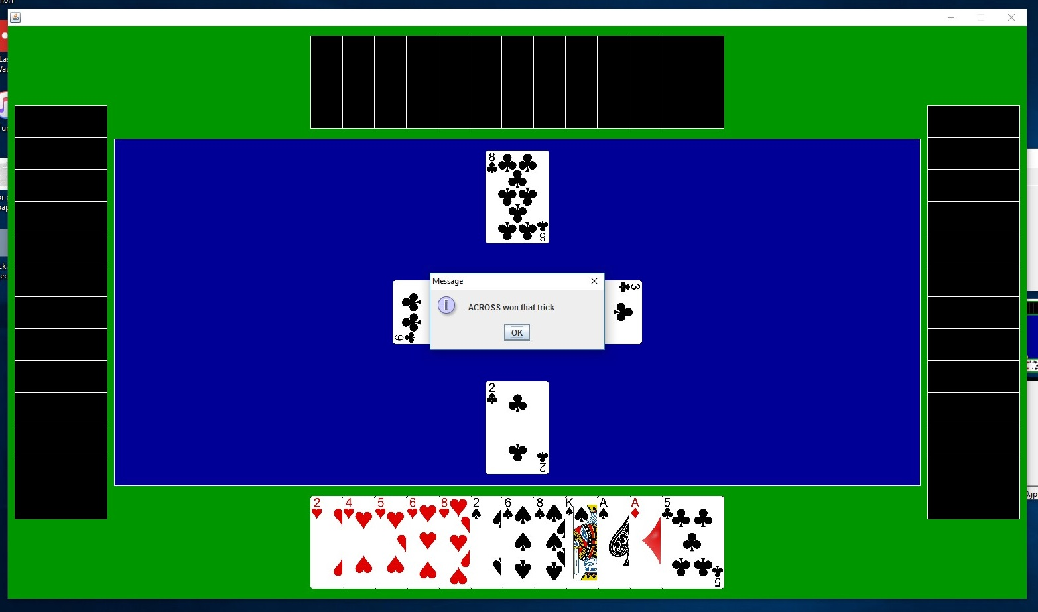
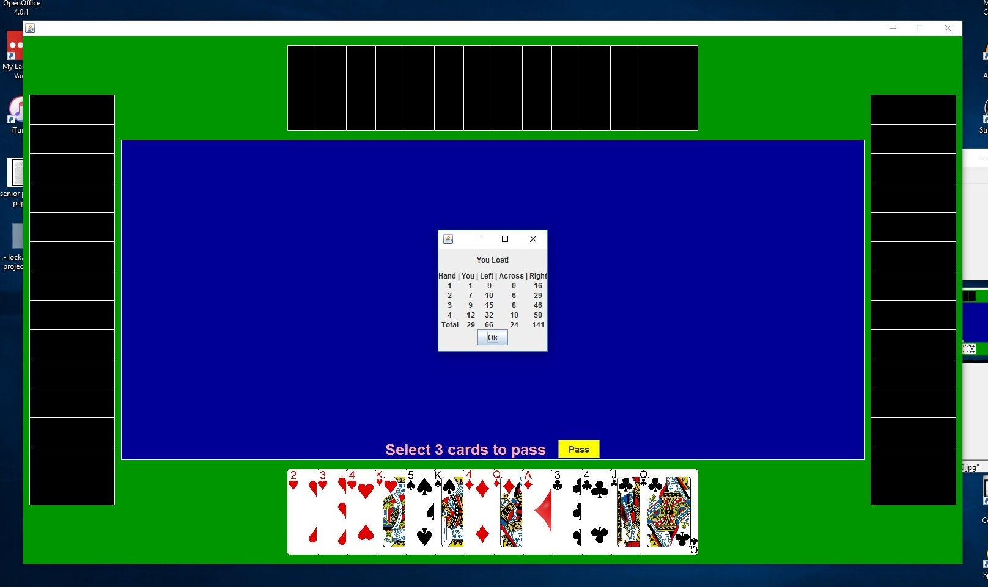
The winner of a trick being announced
The end of a game of Hearts
Design
User Interaction
All interactions are handled by the mouse, namely clicking with one of the 3 standard mouse buttons (left, middle, and right) and by dragging certain elements around the playing areas. When the user boots up the game, they are presented with a main menu which offers them a choice of launching one of the three modules, either Minesweeper, Solitaire, or Hearts. If the user selects “Minesweeper,” they are presented with the choice of difficulty level. The only possible interaction at this point is to click a choice with the mouse.
This main menu is important because it acts as a central hub to dispatch modules as the user decides. It is the first thing that the user sees when they launch the program. When the player wins or loses a game or they exit the module they are in, they are returned to the main menu. In this way, they can launch another game module (or the same one) or decide that they are finished and can exit the program altogether.
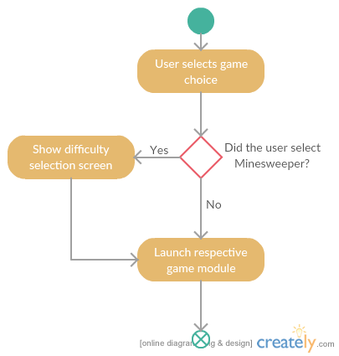
A description of user interaction for the main menu
Minesweeper works very well using a mouse, and it uses all three buttons on a standard mouse. A left click is used to clear a single square, a right is click is used to toggle flag placement, and a middle click is used to clear multiple squares at a time (this can only be done when all squares hiding a mine are presumed to be covered by flags. In this instance, all squares that do not have a flag on them are cleared).
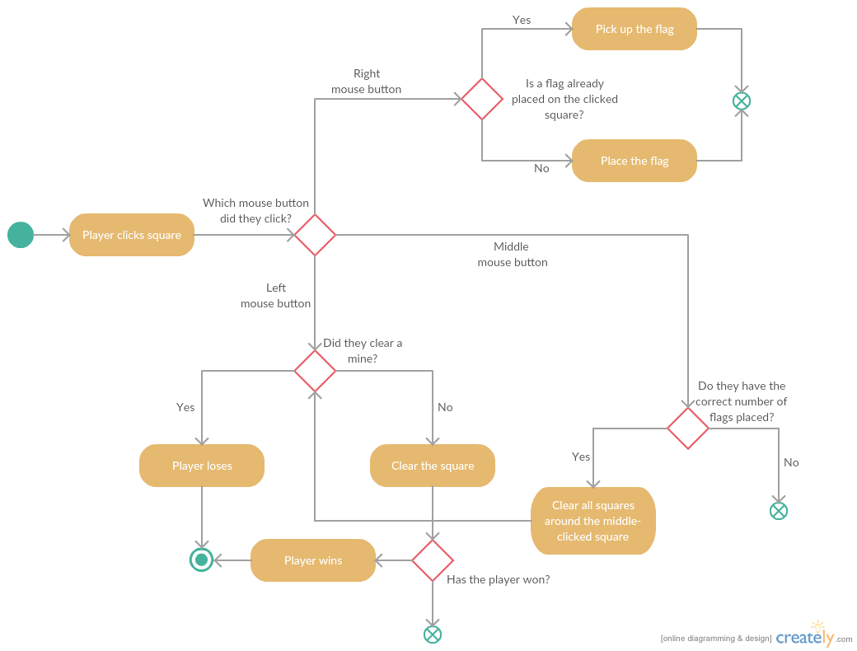
A description of the user interaction during a game of Minesweeper
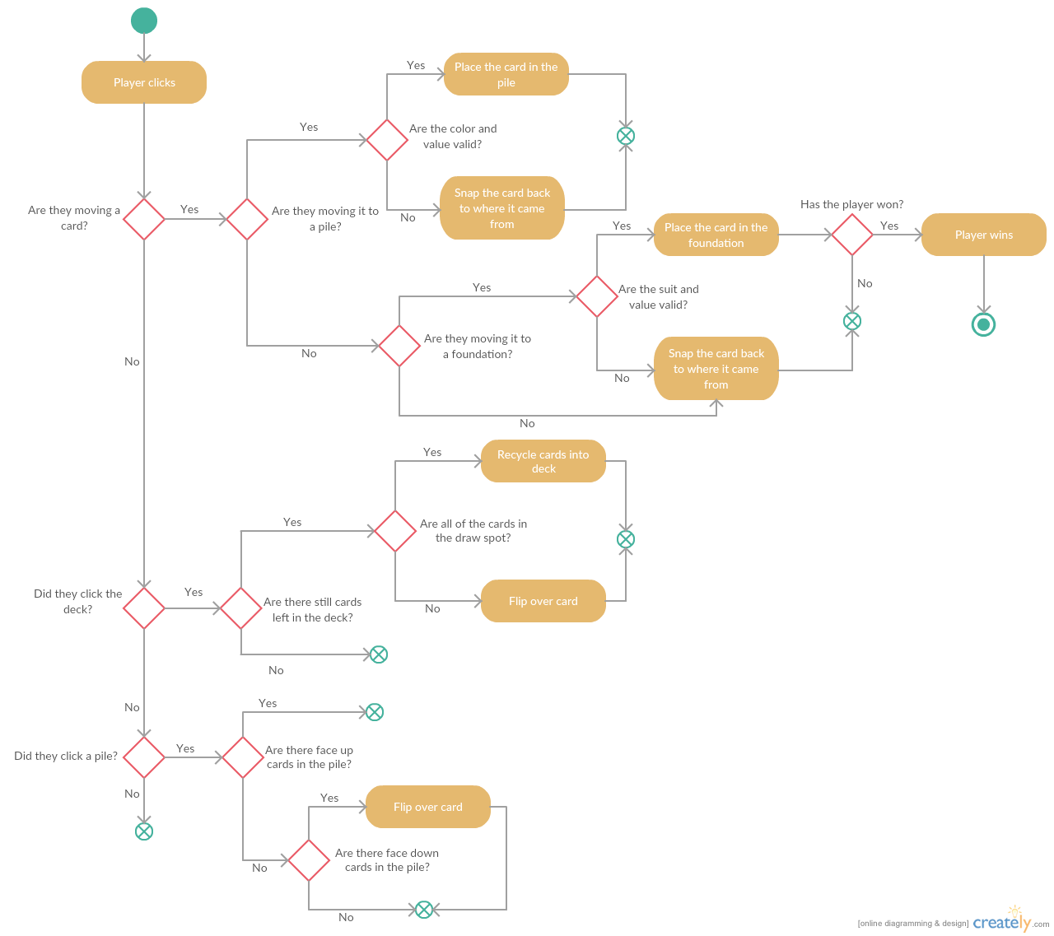
Unlike Minesweeper, Solitaire can be played off of a computer, using a real deck of cards. However, the game lends itself to implementation quite nicely. Cards are moved by dragging and placing the card is done by releasing the mouse button over the desired location. When an invalid move is performed, the card is snapped-back to where it came from. A card is turned over by clicking the left mouse button on a face-down card.
A description of user interaction during a game of Solitaire
Like Solitaire, Hearts was initially played using a physical deck of cards, but can be implemented on a computer quite easily. While dragging cards is also a possible solution in Hearts, after some testing I found that clicking was more appropriate to this game. Dragging cards is unnecessarily difficult to implement, especially given that it makes things feel more sloppy and less accurate.
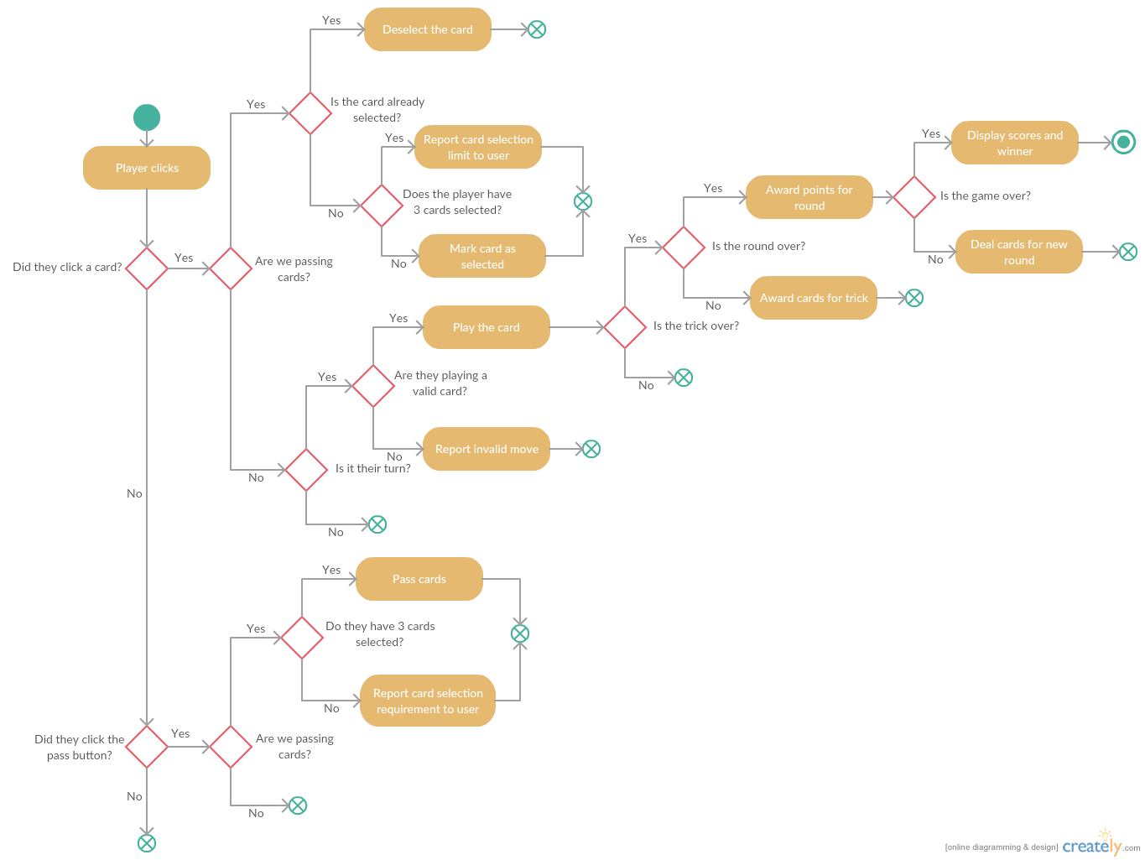
A description of user interaction during a game of Hearts
Event-Driven Programming and Java Swing
Event-driven programming is essentially a series of user interactions and immediate software responses. These user interactions are defined as “events.” When a user clicks somewhere on the screen or presses on the keyboard (or uses some other input device), an event is launched. Event handlers are written as the responses of the program. For example, in a word processor the user can fire off events by pressing keys on the keyboard. The program responds by displaying these keystrokes on the screen. In the downtime between events being launched, the program simply sits and waits for the user to do something. This type of system is perfect for a simple game which uses a GUI and has a limited numbers of inputs.
Java has an enormous library of built-in packages for custom GUI development called Java Swing. JButtons are used to create clickable buttons, JLabels are used to display text, and the list goes on. The full window that is launched is referred to as a JFrame, and this is the object that displays the Swing components. All components that are delivered by Swing behave as objects. In this way, they can be inherited from to create custom GUI classes and instances are controlled by basic dot (“.”) notation.
In addition to its support for GUI's, Java also has a simple-to-use library for event-driven programming. In Java, event-handling objects are called “listeners,” and these responsibilities can be assigned to Java swing inheritors via implementing a listener interface, such as ActionListener or MouseListener. Just about any Java Swing component can be set up to fire off an event when it is interacted with. Also most Java Swing components can be extended to be set up as listeners.
A consistent design during implementation was to organize sub-components such as JButtons and JLabels (or extended Swing classes) into JPanel objects and organize them into their JFrame. This is seen throughout the code.

Model-View-Controller Pattern
The general design paradigm which I followed for the implementation of this project was that of the Model-View-Controller (MVC) design pattern. An MVC lends itself extremely well to event-driven programming, because of the way the user must interact with the GUI in order for changes to occur. With this pattern I was able to easily separate the logic and data, the Model, from the graphical display, the View. Because the incoming data was so simple, with the user only interacting with elements which I could set up listeners for, the View assumed the responsibilities of the Controller.
When a View is created, a Model is also created. The View has a reference to the Model and can control it directly. However, the Model can never reference its View. When the user interacts with the View, the Model is updated. Afterward, the View is refreshed based on the changes to the Model (normally, the Model would be updated by the Controller and the View would then refresh, but I have chosen not to complicate the design by adding the Controller portion). In this way, the GUI which is made by the View is independent of the data being held by the Model.
Classes
For the sake of organization and proper identification, I separated all classes into packages which generally correspond to the module in which they are active. The only exemption to this rule is in the Utilities package, which are classes that are either inherited from or used directly in multiple packages. Because of this organization, the following class descriptions will also be separated by their respective packages.
Main Menu Package
MainMenuView
The MainMenuView class is responsible for displaying the main menu and also listening for and handling user actions when the main menu is being displayed. These interactions include button clicks which are set up as events. MainMenuView extends JPanel implements the ActionListener interface in order to respond to events which are deployed by components that are
This is a very simple class which only needs to display 3 buttons and respond to user input. It launches whichever game module that the user clicks on. There is no need to have a MainMenuModel class because the main menu has no data which it needs to remember and no self-contained that it needs to run through.
Utilities Package
Card
The basic element of the card games Solitaire and Hearts, as both games use this class extensively. This class contains data such as the value of the card (Ace, One, Two, etc.), the suit of the card (Diamonds, Clubs, Hearts, Spades), and whether or not the card is face up. These are instrumental to not only the display of the cards but also to the way these cards are used in the games.
Because cards require a multifaceted comparison (both of the card's value and its suit), it was necessary to override the equals(Object o) function to ensure it was comparing both of these elements individually. Normally, Java would compare references when the context called for a comparison by data members.
CardDimensions
This class is simply a set of measurements and ratios which are used throughout both Solitaire and Hearts as a way to control their displays and layouts.
CardValue
This is an enum which makes it easier to use actual card values rather than having to remember a more arbitrary set of numbers.
The complications for this class arise from the fact that Solitaire uses the Ace as the lowest card and the King as the highest card, whereas Hearts using the Two as the lowest card and the Ace as the highest card. Thus, I needed to write explicit comparison functions which, using parameters, take into consideration the context in which the cards are being used.
CardView
The graphical representation of a card, which extends the JLabel class. Following the MVC pattern, each CardView object is in direct control of a single Card object, and interacting with the Card object is done through this class. This class also holds data about the CardView's height and width, which are for display purposes.
This class extends a Java Swing JPanel. A CardView object uses a .png image to act as the visual face of the card when it is in the up position. This is the pulled from the /res folder and uses the nomenclature: “res/cards/<value>_of_<suit>.png,” which should correspond to the name of the file. Additionally, the CardView class contains the function drawOnLayeredPane(JLayeredPane, int, int) because of the many different situations in which CardView objects would be used. In this way, any JLayeredPane used throughout the project will be able to add a CardView to itself without having to worry about the details.
EndGameView
The display that pops up when one of the games ends. It extends the JFrame class because it is its own window. This basic class only displays whether or not the user has won – based on parameters – and an “Ok” button to continue. For all derivations of this class, when the “Ok” button is clicked, this window as well as the game module window are closed. The user is then taken back to the main menu. EndGameView is the base class for the StatsEndGameView and HeartsEndGameView classes.
GameStats
A GameStats object is used for tracking certain elements of the user's performance during a single-player game such as Minesweeper and Solitaire. This basic model is only used to track time played, given that both Minesweeper and Solitaire use this function. GameStats is the base class for the MinesweeperStats and SolitaireStats classes.
GameType
An enum class to simplify the use of game types, either Minesweeper, Solitaire, or Hearts. This is in place of having to use and remember arbitrary numbers.
Pair
This is a simple class which imitates an ordered pair. It has two elements, x and y, which are the right and left elements of an ordered pair, respectively. An ordered pair class was necessary because of the return limitations of Java, which, unlike C++, does not allow returns via reference. Because of this, when it was necessary to return multiple values, a custom data structure was needed. When the object was returned, the left and right elements were known based on the context in which they were originally set.
StatsEndGameView
A display that pops up when a game which uses a GameStats object (Minesweeper and Soliaire) to track statistics ends. This class inherits from EndGameView and controls the display of the statistics on an individual basis.
This is an abstract class in which any child classes must override the function makeStatsSection(GameStats) which returns a JPanel. The returned JPanel object is then added to the StatsEndGameView, and it sets up the layout of the game's statistics. When an instance of StatsEndGameView is constructed, a general GameStats object is required, but in the context it is constructed in, an object that inherits from GameStats is passed. The object loses its inheritance and becomes a more general GameStats object initially, but its identity is regained in the overridden function when the object is cast as the child class.
Suit
An enum class to simplify the use of Card suits, rather than using arbitrary numbers in the game modules which use cards. Contains Diamonds, Clubs, Hearts, and Spades as options.
Minesweeper Package
Difficulty
An enum class to simplify the creation of a Minesweeper game. Contains Easy, Medium, and Hard as options.
MinesweeperEndGameView
Window which pops up after a game of Minesweeper ends. Extends StatsEndGameView, which implements a JFrame. This class overrides the makesStatsSection(GameStats) to arrange and display the end of the game, as well as the statistics in a MinesweeperStats object.
MinesweeperModel
Controls the logic and data for a single game of Minesweeper, that is from the loading of the game until the player has won or lost. Contains a two-dimensional array of Square objects which represent the board, as well as the number of squares in the rows and columns, the number of total mines in the board, and the number of unopened squares (i.e. squares that have not been cleared). It also contains some constants which are used for setting up the game.
When an instance of MinesweeperModel is constructed, only the difficulty as chosen by the user is necessary, which is used to set member variables such as the number of squares and the number of mines. The actual board is not initialized (i.e. the space for the squares of the board) until the function initBoard(int, int) is called. It is not called until after the first square is clicked to avoid having the player's first click to be on a mine. As per the rules of Minesweeper, the player cannot clear a mine on the first click of the game.
This class also holds information for when the player wins, which is true when the number of unopened squares is equal to the number of mines in the game. It can also check for the number of flags that are set adjacent to the passed coordinates of a square, which is used to determine whether or not a middle mouse click is valid.
MinesweeperStats
Keeps track of the amount of time from the first clearing of a square to the end of the game (either a win or a loss), as well as the number of clicks the player has made and the number of flags the player has left to place on squares. The time spent and the number of clicks are displayed at the end of the game, while the number of flags left is updated as they are placed and displayed above the grid. Left, middle, and right clicks are all tracked as one number.
MinesweeperView
This class controls the layout and displays the information from its MinesweeperModel object, and also updates the model when necessary. It contains a reference to a unique MinesweeperModel instance which it uses to refresh its display. Additionally, it displays the squares of the Minesweeper grid as JButtons, for which it is also a listener, and holds references to a MinesweeperStats object and other JLabels which it uses to display the time and the number of flags the player has remaining. It inherits from the JPanel class.
A MinesweeperView object controls and displays a MinesweeperModel object which it creates within its constructor using the difficulty selected by the user and passed via parameters. The actual display layout for a game of Minesweeper is quite simple. In the center of the window is the grid of JButtons, the latter of which can be of varying sizes depending on the difficulty. It takes up most of the focus of the window. Above the grid is the timer – which records the amount of time from the first click to the last click in seconds – and the number of flags the player has left.. This is all set up and displayed by the MinesweeperView object.
The MinesweeperView class implements a MouseListeneer interface which handles events fired from mouse-clicking events. It is set up to handle left, right, and middle mouse presses, which differ slightly from clicks (a mouse click event contains a mouse press and a mouse release). Particularly, the main way in which the player can interact with the MinesweeperView object is through the grid of JButtons, which are all set to fire off mouse events when pressed.
When the game initially loads, the MinesweeperView object initializes the grid of JButtons to all be blank with a dark gray color. If a square is left-clicked and cleared it is turned a lighter color or will display a number which is the amount of adjacent squares with mines. Similarly, if a valid square is middle-clicked it will clear the surrounding covered squares and if it is right-clicked it will toggle flag placement. The MinesweeperView object is set up to check for and end the game, and creates and displays a MinesweeperEndGameView object when the game is ended.
Square
This class contains the data and logic of a single square in the Minesweeper playing grid. It contains state data including whether or not it has been clicked, whether or not it contains a mine, and whether or not it has been flagged. Additionally a square object knows its coordinates in the playing grid and the coordinates of adjacent squares, as well as how many adjacent squares have mines underneath them.
Solitaire Package
CardStack
A CardStack is any stack of cards which can be either a Pile or a Foundation in a game of Solitaire. This class is the abstract parent of both of those classes. Its only member variable is the cards, which are implemented as a stack. Child classes must implement specific logic about whether or not a passed card can be added to the empty stack and whether or not a passed card can be added to the stack based on its suit and its value. All of these checks are used to validate whether or not a card can be added to the stack.
Adding a card to the CardStack object requires that the card passes the previously detailed checks which are laid out by the child class. The CardStack class only defines the addCard(Card) function and uses polymorphism to institute the rest of the checks. When a card is added, it is pushed onto the underlying member stack.
CardStackView
This class is responsible for displaying a stack of cards in Solitaire. Following the Model-View-Controller pattern, it contains a reference to a CardStack object, and like a CardStack object it is also abstract. It is inherited by the PileView or FoundationView classes and inherits from the JLabel class.
Inherited classes must implement a placeCard(SolitaireView, CardView, int) function. This is the function that is responsible for actually displaying the card in the layout. Because a pile is laid out vertically and a foundation is not, this process must be different in each child class. However, polymorphism simplifies adding to card to the card stack, so the addCard(Card, SolitaireView, int) function calls placeCard(SolitaireView, CardView, int) in order to take advantage of polymorphism.
Foundation
This class controls the logic for a foundation. Furthermore, it inherits from the CardStack class and implements the abstract functions which the latter provide. Unlike a pile, only cards of a specific suit can be placed in a foundation, which is stored as a data member and set when the Ace is placed in the foundation.
There are three functions which the Foundation class must implement due to the fact that it inherits from the CardStack class: checkEmptyStack(Card), checkSuit(Suit), and checkValue(int). Only an Ace can be added to an empty foundation, only a card of the foundation's suit can be added, and only a card which is one value more than the card that is currently on top of the foundation can be added.
FoundationView
This class displays the foundation. It inherits from the CardStackView class and is responsible for implementing the placeCard(SolitaireView, CardView, int) function. Because a foundation's cards are stacked directly on top of one another, the FoundationView stacks its CardView objects in a similar manner. Thus, only the top card of the card stack is shown.
Pile
The Pile class functions in a manner similar to the Foundation class, although it does not have a specific suit associated with it. Instead, the Pile class is aware of its number, increasing from one to seven, from the left side to the right. Also, the Pile class can add and remove multiple cards at a time because of the unique way in which the player can interact with a pile (i.e. they can move a section of the stack at one time). These cards are not checked when they are added, because they are already assumed to be in a valid order. Furthermore, the Pile can determine if it has face-up and face-down cards, which are necessary when determining if a player can flip a face-down card over to be in play.
In addition to the previous functions, the Pile class must implement the checkEmptyStack(Card), checkSuit(Suit), and checkValue(int) methods because it inherits from the CardStack class. Only an King can be added to an empty pile and only a card which is one value less than the card that is currently on top of the pile can be added. For a card of a black suit to be added to the pile, the top card must be red, and vice versa.
PileView
This class displays a pile. It extends the CardStackView class and uses a JLayeredPane to display CardView objects that overlap one another. Similar to the Pile class, it can add and remove a list of cards (in this case CardView objects) and can determine if the PileView has face-up and face-down cards (which consults the appropriate methods in the Pile model).
Like the FoundationView class, the PileView class must implement the placeCard(CardView, SolitaireView, int) method. However, unlike the FoundationView, the PileView must display its cards vertically and overlaying one another. This is done using a JLayeredPane which allows Swing components to overlap. For this to occur, the PileView must keep track of an offset which is used to position the cards. When a card is added, the offset is the amount of space between the top of the PileView and the top of the CardView. Upon the removal of a card (or cards) the offset is reduced accordingly. Special cases must be taken into account, such as when the pile's face-down cards are flipped.
SolitaireEndGameView
The SolitaireEndGameView class extends the StatsEndGameView class and controls the layout of the window which pops up. It also displays the amount of time the player took to complete the game and how many moves the player made in doing so, referencing a SolitaireStats object for the information.
SolitaireModel
Runs a single game of Solitaire, from initialization to when the player has completed the game. This class holds seven Pile objects and four Foundation objects, which correspond to their respective places on the playing field. In addition, it contains the deck and the draw spot, which are stacks of Card objects rather than actual classes (this is because their interactions are very simple).
Upon initialization, the SolitaireModel object creates the standard 52 card deck with Card instances and appends them onto the deck stack. Next, it shuffles the stack and deals the cards into each pile, from one to seven cards depending on the pile number. When a method outside of the SolitaireModel class wishes to interface with a Pile or a Foundation, they must go through a SolitaireModel object. This is to avoid requiring the view object of a specific pile or foundation when information for that card stack is needed.
Furthermore, the SolitaireModel can draw from the deck and will recycle the stack of cards in the draw spot when necessary. It also determines when the end of the game has occurred, which is when each foundation has the 13 cards of its suit.
SolitaireStats
This class extends the GameStats class and is used for tracking information about a game of Soliatire. In addition to the inherited time tracking, the SolitaireStats class tracks the number of moves the player made. Any movement of a card, whether to a pile or a foundation, is considered a move as well as any cards drawn from the deck or a pile.
SolitaireView
This class controls the layout of elements in a game of Solitaire, and queries a specific SolitaireModel object to do so, in addition to updating the SolitaireModel object when necessary. Unlike a game of Minesweeper, a game of Solitaire has many elements and is quite complicated. The SolitaireView class extends the JLayeredPane class and implements the MouseMotionListener and MouseListener classes to respond to its own mouse events.
Corresponding to the MVC pattern, the SolitaireView has a reference to a SolitaireModel object which it controls and displays. Also, it contains numerous data members which form the GUI for a game of Solitaire. These include the JPanels which split the area into sections (these are used for easy positioning and compartmentalization), seven PileView objects, four FoundationView objects, and the area for the deck and its draw spot. It also contains many variables which keep track of component positioning and for stat-tracking purposes.
A basic layout for the game of Solitaire includes an upper and a lower section. The upper section houses the deck and draw spot (the area in which cards are placed after being drawn from the deck) in the left side and the foundations on the right side. On the other hand, the lower area only holds the piles.
The SolitaireView class responds to all mouse events that occur during the game. First, when a user left-clicks, the class determines the context: whether the player wants to draw a card from the deck or from a pile. All other clicks are ignored. When a player clicks on the deck, a card is drawn from the deck and placed into the draw spot, and if the player clicks on the deck when all of the cards are in the draw spot, the cards are recycled back into the deck in the same order they were drawn in. To determine whether a player has clicked on a pile, the coordinates of the click are analyzed. If it is determined the player has clicked on a pile and the pile is open and has face-down cards, the card is flipped. Otherwise the click is ignored.
A mouse press is different from a mouse click in this context, because a mouse press on a CardView object precedes the dragging of that object. When a player presses on a CardView object, the original coordinates of that object are saved. This is to return the card to its original position, should the player release the card in an invalid position. During the dragging of the card, the CardView object is moved using a setLocation() function provided by the Java Swing library.
The releasing of the mouse is the most complicated process for the SolitaireView class. This is because of the amount of testing that needs to occur to determine if the card has been placed in a valid position, or even if it has been placed over anything worth testing for. To begin, the coordinates of the mouse release event are tested to determine if it has been placed over a pile or a foundation, or neither. In either of the first two cases, the card is tested to see if it the movement is valid by consulting to underlying Card object. If this test is also passed, the card is moved to its new location; if it is not in a valid position it is returned to its original one.
One important thing to note is the onPack() method. This method is used to position the FoundationView and PileView objects which must be done after the frame is packed because it depends on numbers which are not initialized until after this happens. It is necessary that the parent class calls this function after the frame is packed but before control is transferred to the frame.
Hearts Package
Computer
This class controls the logic for the computer players during a game of Hearts. It extends the Player class and implements the functionality for getPassingCards(), trying to find three good cards to pass. Namely, it runs through a list of cards that were predetermined to be good passing cards. Next, if three cards are not accrued, the computer tries to void a suit of cards, taking from the highest cards of that suit.
Another main function of the Computer class is the algorithm for choosing a card to play during a trick. If it is the first turn of the first trick, the computer plays the Two of Clubs. There is no choice but to do this. Otherwise, if it is just the first turn of any other trick, play the highest card of the suit with the fewest cards left in it, in an attempt to void that suit as soon as possible.
The logic for a regular turn of Hearts is somewhat more complicated. First, the computer totals the amount of points for each valid move. Then, it determines which moves would score the fewest number of points. Afterward, it chooses the card of the highest value from that list. However, if either a King or Ace of Spades has been played in the trick, the computer will always play the Queen of Spades. This is to ensure that the computer does not win the Queen of Spades, which is worth 13 points. Additionally, the computer will want to get rid of its highest Hearts card if the trick suit is not Hearts. This is to avoid winning as many Hearts cards as possible, which are each worth one point.
ComputerView
This class controls and displays a single Computer instance and also extends the PlayerView class. The ComputerView adds cards as an overlapping row of black JLabel objects, which is to show the cards as being face-down. One important aspect which the ComputerView class must take into account is whether it is displaying a vertical row of cards, like in the case of the left and right directions. In these cases, the layout must be changed to allow for the cards to be overlapped vertically instead of horizontally.
HeartsDirections
An enum to clarify the use of directions in a game of Hearts. Contains LEFT, RIGHT, ACROSS, and HUMAN as choices. The HUMAN option designates the direction that is directly in front of the player. These options are not only used to signify the direction in which the cards will be passed for a given round, but also the position of the player from where a card is played.
HeartsEndGameView
The HeartsEndGameView class extends the EndGameView class and controls the layout of the window which pops up when the game ends. Rather than displaying statistics for the game of Hearts, the HeartsEndGameView object shows the breakdown of scores by round.
HeartsModel
This class maintains all of the data about and contains the logic to run a game of Hearts. These include references to each player, as well as whose turn it is and the number of the current round. There are also data members that inform on whether a certain card can be played, such as the trick suit, whether it is the first turn, whether it is the first trick, and whether Hearts has been broken. It also contains the cards that have been played and are currently involved in the trick.
A game of Hearts is initialized with a standard deck of 52 cards, with an Ace being considered the highest card in the deck (unlike Solitaire). The cards are shuffled and 13 cards are dealt to each person. Before the round can begin, each player is queried for the cards they would like to pass. Then, the first player for the round is determined to be the player with the Two of Clubs. Turns proceed in a clockwise order.
The HeartsModel class is responsible for determining whether a given card can be added to the trick, and runs through all appropriate logic to do so. When the trick is over (i.e. every player has played a card), the HeartsModel will determine the winner of the trick and give them the trick cards. However, the HeartsModel cannot end the trick or end the round by itself, because the flow of the game is dictated by the HeartsView class. The HeartsModel class can only query the players for information about the end of the trick, the round, and the game, and respond appropriately to these situations.
HeartsScores
This class keeps track of and displays the scores of each player in a game of Hearts. It extends the JPanel class and arranges the scores of each round in a row. At the bottom of the rows, it shows the total scores for each player.
Rather than having a separate object which remembers these scores, the scores are remembered by this class by updating the scores at the end of each round. In this way, a new row is appended onto the bottom of the grid with the amount of points each player scores in a single round, and the total scores are updated accordingly.
HeartsView
The HeartsView class controls and displays a unique HeartsModel instance, following the MVC pattern. It extends the JPanel class and implements the MouseListener and ActionListener interfaces. Most of the interactions are being done with left-clicks, as most of the interactions include choosing a card to play during the player's turn. The HeartsView class listens for and responds to these events.
There are only two basic elements to a game of Hearts, the trick and the hands. In simulating an actual game of Hearts, the trick area is positioned in the middle of the window while the players and their decks surround it.
In the beginning of a round of Hearts, each player must choose exactly three cards to pass in the given direction. At this time, there is a message displayed in the bottom of the screen to indicate to the user to select their passing cards. The player must then click on three cards, which are highlighted when selected, and then click the “Pass” button.
As previously stated, the player must click on a card in order to play it. However, these clicks on the player's deck which occur after cards have been passed are ignored if it is not the player's turn. This is perhaps the biggest difference in design between Hearts and the other two games: because we must wait for the computer to be done with their turns, the HeartsView class must be responsible for knowing and announcing whose turn it is. These announcements are made via pop ups which must be acknowledged (by pressing the “Ok” button) to be dismissed. They announce when it is the player's turn, which move the computer has made, which player won the trick, and the scores at the end of the round.
Human
This class extends the Player class, and is quite barebones because of the fact that most of the logic in this game is done by the player, rather than the computer. The only important note to make is that the getPassingCards() function returns a data member rather than running through a system of logic like the Computer class does.
HumanView
Displays the cards as given by its Human object. It extends the PlayerView class. Unlike the ComputerView, the actual faces of the cards are being displayed. Thus, it must use actual CardView objects instead of just JLabels. Also unlike the ComputerView, the HumanView class is only ever being displayed horizontally.

Player
This is the base class for all players of Hearts, which is thereby extended by the Human and Computer classes. It holds the deck, the cards the player is choosing to pass, and the cards the player has won. Additionally, this class contains the position of the player at the table (stored as a HeartsDirections member variable) and how many points the player has scored in one round and also their overall score.
One of the few non-standard methods in the Player class is the sortDeck() method, which sorts the player's deck through a custom sort function. This function, called a Comparator in Java, is passed to the ArrayList's sort function and, in our case, overrides the compare(Card, Card) method. Because a card has two elements to compare, the card's suit and the card's value, this comparison overload is necessary. Using this Comparator, the deck is sorted by suit (Hearts, Clubs, Diamonds, Spades) and each suit is also sorted (Two, Three, … , Ace).
For a class to inherit from the abstract Player class, it must define a getPassingCards() method. As previously detailed, the Computer class runs an algorithm in this overriden function while the Human class waits for player input to determine its passing cards.
PlayerView
Similar to other view classes, the PlayerView class controls and displays a Player model. It uses the JLayeredPane and offset functionality detailed in the Solitaire section to overlap the cards in the player's hand. For a class to extend the PlayerView class, it must define the addCards(HeartsView) method which is used to lay out a player's hand. Another method important to the layout of the player's hand is getCardsAreaSize(). This function calculates and returns the amount of space that the player's hand will occupy, which the HeartsView object must know so nothing important gets cut off.
RotatedCardView
This class extends CardView and is used in Hearts when a card is played from a position other than the player. In a game of Hearts, cards that are laid out in the center are the cards in the trick. These cards are rotated in a way that they reflect the position from which they were played. Unfortunately, attempts to rotate the component itself were very buggy, and my research into finding a good solution led me to applying code written by a certain Aleksandr Movsesyan from StackOverflow.com. Essentially what his code is doing is performing an affine transformation onto the image of the card which was pulled from the /res folder. If the card is displayed horizontally (i.e. it came from the left or right position), the height and the width of the CardView are swapped. Then the image is applied to the component in the same manner it is with a CardView object.
TrickView
This class displays the large area in the center of the Hearts layout, called the trick area. It is responsible for laying out the cards that are played by each player, and also displaying the passing message in the beginning of a new round. The TrickView class was created as a way to compartmentalize rather than for function; its layout became quite complicated due to the tendency of Java Swing layouts to center themselves, which looked strange when cards are supposed to be placed in a position reflective of the direction from which they came. Because of this, the TrickView class is not itself an ActionListener, but rather the “Pass” button is handled by the MainMenuView.
Turn
Like the Pair class, the Turn class was created due to the limitations of Java, in that I was unable to return multiple values from functions. A turn consists of the card that was played and the position of the player who played it. All methods within this function, apart from the constructor, are getters and setters.
Conclusions
Introduction
overall feelings
One of the most important aspects which came up during the planning phase of this project was the language in which it would be written. Java came to mind immediately because of the experience I had in using the Java Swing library, and also because I had never used C++ to create a GUI application. Although I was much more familiar with C++ than with Java, I believed it would be easier for me to learn the intricacies of the latter than adapt the former to a completely unknown GUI API. Also, Java is a very popular language, and becoming more comfortable in that environment could also be important down the road.
Java feels like an incredibly pleasant language to program in, given a background in C++. The syntax is very similar, yet Java improves upon many of the shortcomings of C++. First, Java doesn't have pointers. Pointers are an interesting topic for students and their introduction gives students a good look at what the computer is actually doing (which makes C++ very good for a first look at programming). However, they quickly make coding complicated, and their absence in Java ensures that I can focus on the bigger picture, rather than whether or not I have a memory leak. I don't want to be concerned about the way I'm handling operating system resources, because that should be the job of the language.
The above is one example of the differences between programming in Java and C++, and an illustration of the general pattern that each language follows. C++ (adapting from C) was designed to be extremely quick and give programmers as much control as they would want, perfect for system applications. But Java is more a language geared for general use, and fit wonderfully with the requirements of this project. And while I do have some affinity for C++, mostly due to the fact that is the first language I ever learned, it suffices to say I prefer to program in Java.
One thing I have come to appreciate over the course of the last few months is the sheer amount of time and work projects of this scale take. From planning, to development, to testing (and then back to planning, to development, to testing, to planning, etc.), so much attention to details both small and large must be paid to ensure one has a viable product. This is another thing I have come to appreciate, not only during this project but in my experience in this field of study: that programming can be entirely unforgiving. It is possible to work for hours upon hours on a programming assignment and come away with something completely unusable, unlike my experience with writing which, so long as one can put words onto a paper, one can have something to show for their work at the end of the day. If a deadline hits and your program still crashes, there's not much to do about it.
Out of the three modules, Minesweeper is by far the most solid, meaning it is the one with which I had the least amount of trouble. The layout is relatively simple, as it is only a grid. Similarly, the handling of mouse events is very straightforward, as the responses for left, middle, and right clicks are all clearly defined. A game of Minesweeper has only a handful of variables that need to be tracked, and very limited pathways for user interaction. Although Minesweeper was probably the most simple part of this project, it is Solitaire which I am most proud of, if only because of the number of complications.
Solitaire was the module with which I had the most trouble. To begin, cards in piles had to be laid out so they overlapped, which I originally had no idea how to do. My original plan was to use a layout manager provided by the Java Swing library, but that ended with bugs such as the cards not appearing as the correct size. Eventually, I found out about the JLayeredPane which fit my needs exactly, however I ran into problems with that as well. For example, a JLayeredPane does not use a layout manager, and thus all components in the JLayeredPane must be positioned and sized explicitly. All of this research, experimentation, and debugging took a lot of time which I had not originally planned for.
After I began to implement my JLayeredPane solution, I noticed troubles with actually dragging the cards around. Although the cards would move where I wanted them to, they would disappear when outside the boundaries of their layout objects (i.e. the PileView to which they belonged). The solution to this was to position the top, movable cards such that they were actually added to a foreground panel which rested on top of all the other components. When a card was added to a pile, the old movable card was added to the PileView and the new card would be added to this foreground panel. This design had to change when I realized that not only the top cards in a pile were movable, but any face-up card in the stack could be moved. Thus, all face-up cards are a part of the foreground panel, which itself became a JLayeredPane.
The next element of the Solitaire module that gave me trouble was being able to click piles and place cards. Although the Java Swing library supplies methods which are supposed to return the position of a component, I found that these were often unreliable (perhaps this was due to my use of JLayeredPanes, but my testing suggests otherwise). In addition, the methods for determining if two components were overlapping were too strict to be used in this context. My solution to both of these problems was to record the positions of piles when the game begins, and test whether the mouse events happened over the components with simple integer comparisons. All in all, together with the snap-back feature I implemented when releasing cards, I believe the Solitaire module plays quite well.
The development of Hearts went by rather smoothly. By the time that I began the work on this module, I was already much more familiar with Swing, to the point that my knowledge of the API drastically improved my planning ability. Perhaps the only major research and experimentation that needed to take place, besides basic UI development, was in how to achieve the effect of a rotated card. As described in the previous sections, I was able to apply to my project a method that I found online which worked splendidly.
Nevertheless, I must include the part about this project that I am most disappointed in, and that is the computer's AI routines. This is mostly due to the fact that the Hearts module was developed last, and time was a limiting factor. As such, I wasn't able to play enough Hearts to create what I believe to be a good algorithm for choosing moves.
One of my biggest wishes was to have created something that just looks more pretty. From the onset, I was determined to first worry about function and user experience, then aesthetics. However, time restrictions limited my attention the latter. I don't think my project looks ugly; if I thought it did, I wouldn't have submitted it in its current state. Though, it lacks a certain polish that is present on most finished software, and on software that is put out by companies trying to sell products. During an internship, I was exposed to some front-end development, and there was always artwork that was being created by a different team that I was using to match their designs. Although I had less experience at that point, the end product seemed nicer because it looked neat and professional.
Conclusion
reiterate overall feelings

